Standardized Economic Assessment (SEA) Tool for Economic Evaluation of Chemical and Energy Plants

Carlos Arnaiz del Pozo1

Schalk Cloete2

Ángel Jiménez Álvaro1

1 Universidad Politécnica de Madrid, Departamento de Ingeniería Energética

2 SINTEF Industry, Flow Technology Group

# Purpose

The current document aims to familiarize new users with the Standardized Economic Assessment (SEA) Tool developed jointly by the Flow Technology Group from SINTEF and the Department of Energy Engineering from Universidad Politécnica de Madrid in Microsoft Excel. This tool intends to provide a convenient, generic, and transparent methodology for the economic analysis of chemical and energy plants, with a particular focus on sustainability.

The SEA tool is designed for researchers dedicated to early-stage process synthesis who seek a flexible economic evaluation support to assess the attractiveness of their incipient designs. Where possible, the cost estimations provided within the tool are consistently benchmarked against available cost references in literature, to allow the user to judge the accuracy of the estimation and select the most appropriate approach in their evaluation.

Over time, the tool will be further advanced by the authors and other researchers who want to utilize it for their own works (find the latest version [here](https://github.com/SINTEF/Scale-Coupled-Open-Innovation-Network/blob/main/Economics/SEA%20Tool%20-%20Template.xlsm)). The final aim of the SEA tool is to facilitate direct comparisons between novel process configurations designed by different groups, particularly in the framework of energy systems modelling. This standardized methodology will accelerate the process of identifying the most promising concepts for scale-up in future energy systems with high shares of variable renewables and sector coupling.

Practically, the SEA tool will also facilitate simplified and more transparent communication of methods for economic assessment – particularly when it comes to open scientific publication. The tool is licensed under a [General Public License](https://www.gnu.org/licenses/gpl-3.0.txt) that allows users to freely share, create, and adapt, provided that derivative works are shared under the same license and kept open access. In conjunction with this manual, open economic assessments based on the SEA tool can be linked from the methodology section of academic articles to shorten and simplify the description of the economic methods.

# Capital Cost Breakdown

The capital cost levels for “overnight costs”, expressed for a chosen target basis (defined by a year, currency, and location), are determined following several high-level reports [1-4]. Figure 1 shows an overview with the terminology and acronyms employed.

The plant under investigation is subdivided into specific, differentiated sections designated as units. The cornerstone of the SEA tool is to provide a reasonable estimate of the BEC for each unit of the plant. The source basis currency, cost year, and location depend on the cost correlations references of the original source employed. Since different units can be assessed using data from diverse sources, the cost of each unit is adjusted to the target cost basis using an exchange rate, Chemical Engineering Plant Cost Index (CEPCI), and location factors (to account for material and labour cost differences between different world regions). For instance, the cost estimation in the source basis (), is adjusted to the target basis () as shown in Eq. 1:

|  |  |  |
| --- | --- | --- |
|  | Eq. 1 |  |

Here, is the currency exchange rate from basis A to B, and is the relative factor for labour and material adjustments between regions. These factors, have been obtained with weighted material and labour relative values provided in [5]. CEPCI factors are taken from [6].

The BEC accounts for the costs of purchased process equipment, facilities, and infrastructure as well as the direct and indirect cost required for installation. The TPC comprises the costs of EPC (engineering, procurement, and construction) services and contingencies. Process contingencies are considered in this cost item, representative of the extra capital incurred to cover the uncertainty related to specific components or units of the plant which may present a lower level of technological maturity, designated with a Technology Readiness Level (TRL) indicator. Initial cost estimates of such units tend to be optimistic due to simplified modelling and a low level of design detail, and the process contingency serves as a method to correct for this common bias. In addition, Project contingency accounts for extra capital allocation due to site-related risks of the plant being deployed. To determine the TOC, the owner’s costs are added, which include the costs of land, financing, permits, fees etc. Finally, the TCR represents the total capital expenditures during the construction period, including interest and cost escalation.



Figure 1 Capital cost breakdown

## BEC Estimation Methods

The SEA tool aims to achieve a reasonable balance between detail and accuracy on the one hand and generality and user-friendliness on the other. A balance is also found between user flexibility to customize several technology components while achieving a reasonable degree of automatization to simplify the workflow. Provision is made for sizing of equipment where other software may be used as support.

For BEC estimation of the plant units based on individual equipment cost correlations, the *Equipment* approach is followed. This approach makes use of purchased cost correlations adjusted with material, pressure, and bare module factors to determine the BEC of each unit. For the assessment of process units where important equipment-level costs are not available, the cost-capacity *Scaling* approach from suitable references available in literature is followed.

### Equipment Approach

The basis for estimation of the BEC of each individual equipment comprising the plant unit is the correlations from the handbook Analysis, Synthesis and Design of Chemical Processes by Richard Turton [7]. The purchased costs of equipment in $ are normalized to the year 2001, while the bare module factors of the units to represent field installation costs are obtained from [8].

The purchased cost is adjusted with the following logarithmic expression (Eq. *2*), for a unit operating at ambient pressure and using carbon steel as construction material:

|  |  |
| --- | --- |
|  | Eq. 2 |

With being the capacity or size parameter of the equipment, within maximum and minimum limits. , and are specific to each type (and subtype) of equipment.

For operating pressures different from the ambient, a mathematically analogous pressure correction factor is employed (Eq. *3*). In the SEA tool, the absolute pressure must be specified for correct calculation.

|  |  |
| --- | --- |
|  | Eq. 3 |

For vessels, an item which is often employed to determine reactor costs when no other information is available, the pressure correction factor is calculated according Eq. 4:

|  |  |
| --- | --- |
|  | Eq. 4 |

Where is the absolute pressure (bar) and is the diameter (m). is always greater than 1, and when considering pressures lower than 0.5 bar, a value of 1.25 is taken.

Finally, factors for different materials of construction are given tabulated for each equipment subtype, and the bare module factor is calculated with Eq. 5. For certain equipment, the bare module factor may be provided directly with a value for . Equipment specific correction factors are considered for a small number of equipment subtypes. The bare module cost is determined by multiplying the purchased equipment cost under reference conditions with the bare module factor:

|  |  |
| --- | --- |
|  | Eq. 5 |

is determined within the equipment capacity bounds. When the upper limit capacity is exceeded, a capacity cost scaling law is applied (similar to the formulation described in the next section), with an exponent selected by the user. The user should judge whether the scaled cost resulting for the equipment is reasonable. The authors have verified that the scaled values with an exponent of 0.67 give comparable results for common equipment units such as compressors, turbines and heat exchangers (fixed shell & tube) relative to correlations from [9] with a larger capacity limit. The user may consider if different scaling exponents should be used based on their experience or following recommendations for the exponent of each equipment type as suggested in [10].

### Scaling Approach

The SEA tool aims to build process units up from individual equipment lists whenever possible. However, this approach is not feasible for certain specialized equipment (e.g., gasifiers). In this case, the scaling method for BEC estimation is employed, relying on one or more suitable references with cost assessments of the same unit scope. This approach introduces the economies of scale principle: a nonlinear relationship where, as the facility becomes larger, the specific cost (cost per unit capacity) is reduced. Furthermore, the generalized formula considered in the tool contemplates the possibility of train cost reductions when several trains () are built both in the reference and novel facility, each operating at of the total capacity. This is a consequence of the fact that some synergies are gained leading to cost reductions when an additional train of a unit is constructed for a given facility. The generalized formula is outlined in Eq. 6:

|  |  |
| --- | --- |
|  | Eq. 6 |

Where the subindex indicates the reference cost and capacity , and represents the unit exponent, while the train exponent. Typical values for and are 0.67 and 0.9, respectively.

Several literature sources provide cost breakdown values for relevant units such as gasification technologies, air separation units, acid gas removal plants, steam cycles and many more. In Table 1, a short collection of references, which have frequently been used by the authors in the past for evaluation of novel power systems with CCS, are listed.

Table 1 References for capital cost estimations of power generation units

|  |  |  |  |
| --- | --- | --- | --- |
| Source | Publication Year | Organization | Reference |
| European Best Practice Guidelines for Assessment of CO2 Capture Technologies | 2011 | European Commission | [11] |
| Cost and Performance Baseline for Fossil Energy Plants | 2007  2013  2015  2018 | NETL | [1-4] |
| CO2 Capture at Coal Based Power and Hydrogen Plants | 2014 | IEAGHG | [12] |
| Oxy-combustion Processes for CO2 Capture from Power Plant | 2005 | IEA | [13] |

# SEA Tool

In this section, the methodologies described earlier are integrated in the developed spreadsheets. Examples of a specific evaluation are shown, acknowledging that the user may modify or create new sheets based on the templates created depending on their specific needs. To make the Excel spreadsheet more user friendly, the colour coding used for the cells is presented in Table 2:

Table 2 Colour coding employed in SEA tool

|  |  |  |
| --- | --- | --- |
| **Colour** | **Action** | **Description** |
|  | Specify | Input value or text |
|  | Select | Choose from drop down menu |
|  | Calculated | Result of a formula or determined |
|  | Notes | Text, comments the user can add |

## Plant Overview

In this tab, a general overview of the plant subject to evaluation is presented. It consists of several sections that can be freely manipulated to facilitate the wide range of plants that can be assessed with the SEA tool. In the top left corner, the target basis for economic evaluation must be specified. The user can select with drop-down menus the targeted year, location, and currency for the economic analysis target basis. A wide range of locations are available, and new regions can be added in future. On the other hand, the user must perform the evaluation either in Euros (€) or Dollars ($). The year cost estimation basis ranges from 1995 onwards, and future years can be selected for projected economic evaluations provided that the user supplies a CEPCI prediction beyond the present time.

Next, the technical performance of the plant (from a separate process simulation) is summarized for easy access in the economic assessment. In the Energy & Mass Breakdown section, the user can specify the values of power producers and consumers within the plant. The basic net and gross thermal balances and total auxiliary consumptions, as well as net and gross efficiencies can be calculated in this section. Given the particular focus on sustainability underlying the economic assessment tool, a specific region to reflect the plant environmental performance is available below the energy breakdown. Finally, beneath this section the user can specify the fuels and raw materials involved in the plant, as well as making specific calculations for these. The user must specify (at least) one plant main product, one emissions item (in principle this first emissions parameter is linked to the CO2 emissions costs in OPEX sheet) and up to two fuels or main raw materials consumed by the plant. Naturally, given the large variety of energy sources and performance metrics definitions, these areas of the spreadsheet are open to modification depending on the characteristics of the plant investigated. Care should be taken to ensure that the cells employed for calculations in other tabs are correctly referenced if required.

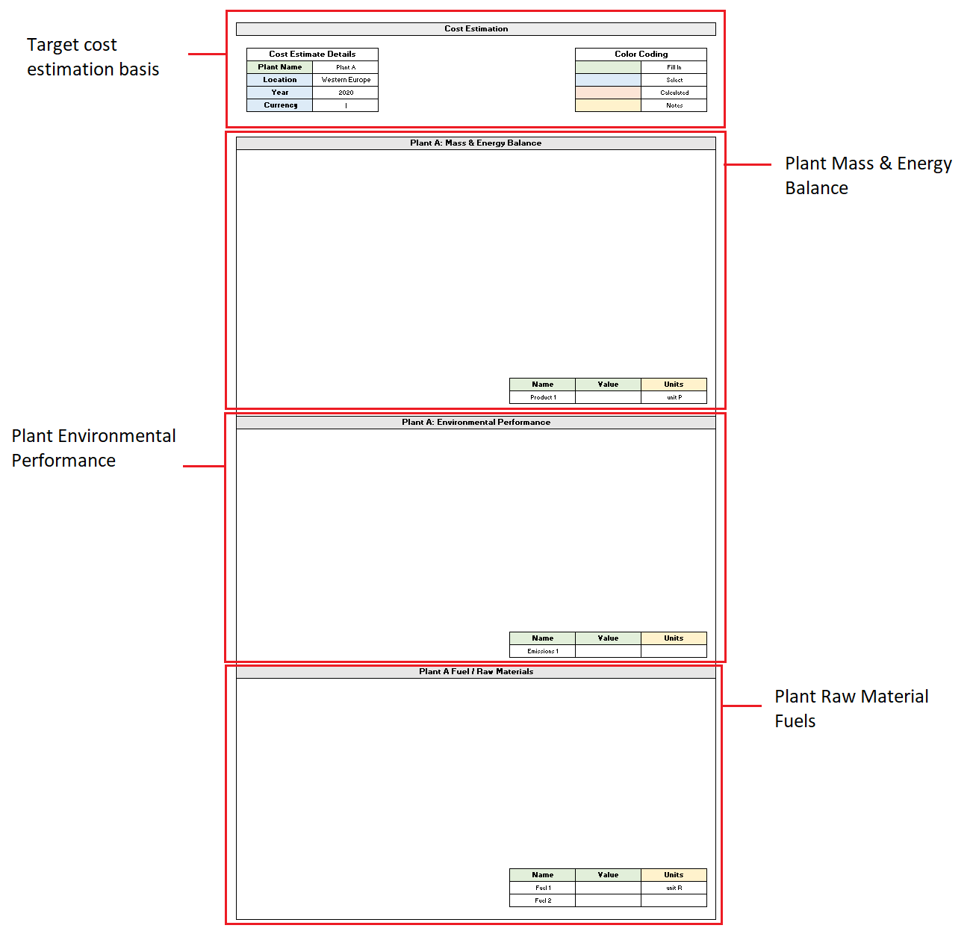

Figure 2 Plant overview: specification of cost evaluation basis, energy breakdown, environmental metrics and fuel/raw materials

The right-hand side of the “Plant Overview” tab provides space where the user can input a visual representation of the plant, with a stream summary further to the right. Below the plant diagram, the user can provide a written description of the plant, and beside this a list of the plant units (sections) considered in the evaluation is detailed. The names and codes of these units are linked to the appropriate sheet of each unit. These items are reflected in Figure 3:

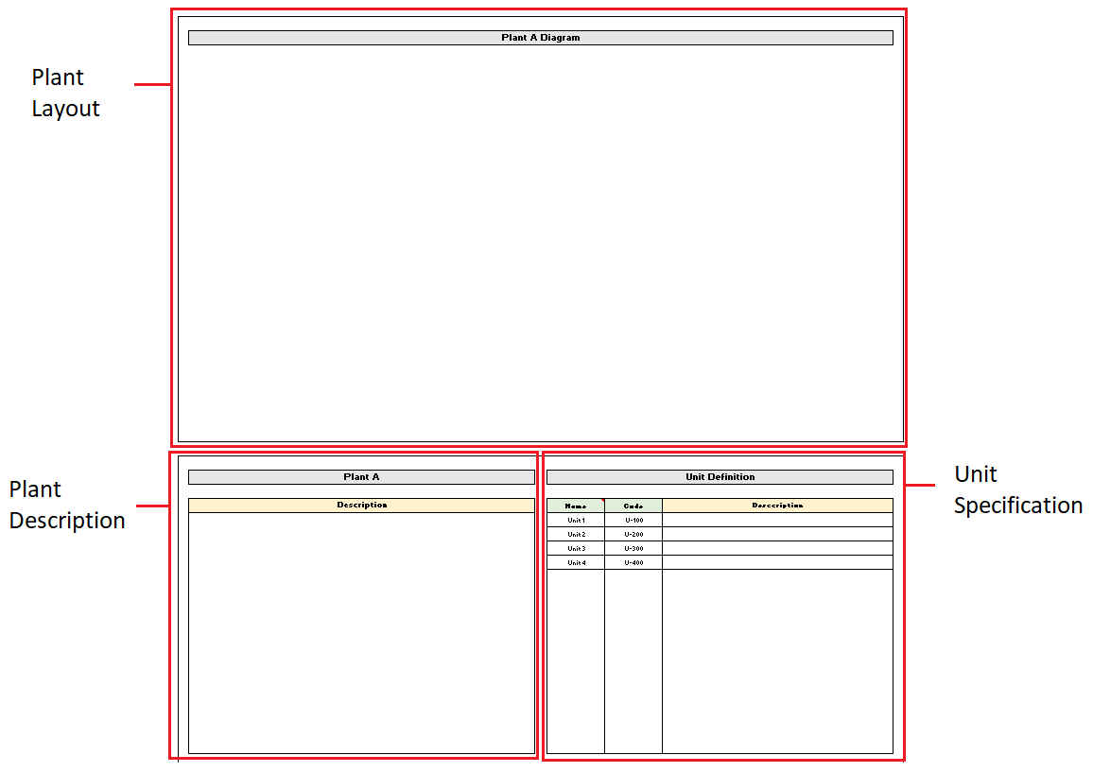

Figure 3 Plant overview: plant Layout, and Unit specification

Finally, in the lower left region of the spreadsheet, a quick access menu with buttons to the key evaluation tabs is shown, as depicted in Figure 4. Besides, a menu to create a stream summary table is available. The user can define the nº of streams, properties (temperature, pressure, flow rate etc.), and components (to input stream compositions) that are considered in the table with the add/remove buttons.

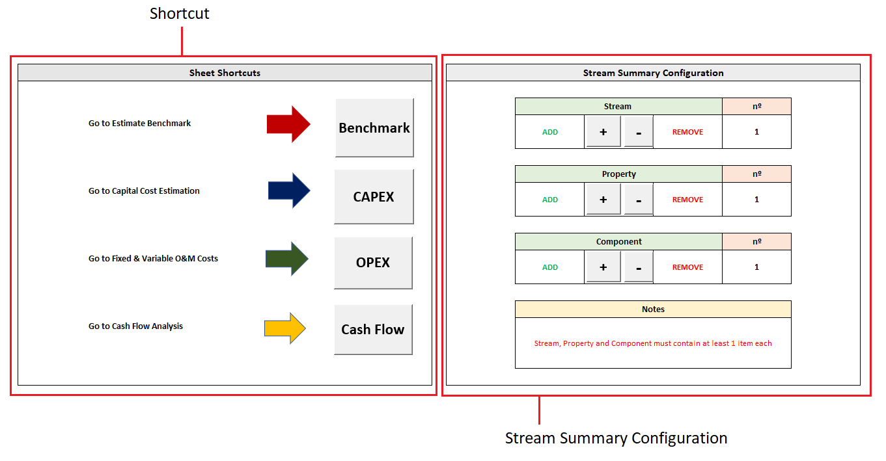

Figure 4 Shortcut buttons for navigation across the spreadsheet and stream summary generation

The stream summary table is customized by the user and in Figure 5 a representation for 1 stream with 1 property and 1 component is shown.

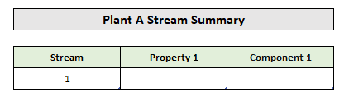

Figure 5 Plant stream summary

## Unit – X0X – Equipment

This tab refers to the plant units whose cost is determined following the *Equipment Approach* described in section 2.1.1. An example for the cost estimation of a unit is presented in Figure 6. The user must identify the equipment elements of which the unit is composed and add suitable items with the drop-down menus. The capacity (size) for each equipment must be introduced in the corresponding units, as well as the operating pressure. Once equipment type and subtype are selected with the drop-down menus, the units at which the capacity value must be introduced is automatically shown. The materials of construction can be selected with a drop-down menu as well, and are specifically restricted to those available for each equipment subtype. For certain equipment, in the column “other spec” an extra variable for the calculation of the unit cost must be introduced (i.e. for vessels, the diameter in m is required to determine the pressure factor). In such a case, a message requesting a specific input will be prompted in the corresponding cell for the cost calculation.

The user is referred to the master sheet available in the tool, Unit-X00 Equipment, to select and paste the formulas for each equipment type for the calculation of , , , , in the unit sheet. It is convenient to copy the entire row of the required equipment between rows D and Q to the unit sheet that is being constructed. Then, the appropriate modifications can be made manually regarding the capacity, material, and operating pressure.

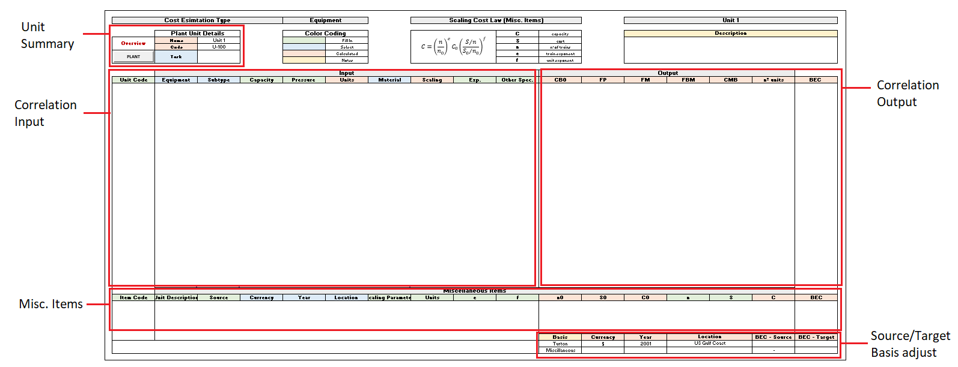

Figure 6 Equipment Estimate: unit summary, correlation input & output, Misc. items and BEC adjustment sections

In the top left corner, a short summary of the unit is given, with a specific code and a fundamental task drop down menu selection. Fundamental tasks is a method of categorizing the unit with regards to the function it carries out within a plant. Also, a quick access button to the Plant Overview sheet is included to the left. Below the standard equipment input region, a small space is available to introduce other miscellaneous items of the cost estimate which are expressed in terms of specific costs, with a certain capacity introduced to calculate total costs. Finally, in the bottom right of this section, the BEC estimates in the corresponding basis are presented; Basis 1 (US Gulf Coast, 2001 and $) always corresponds to the correlations from Turton for an equipment estimate, while Basis 2 can be used for adjusting costs from the Miscellaneous Items list. In the cell to the left, the BEC adjusted to the targeted conditions specified in the top-left corner of the Plant Overview sheet is presented.

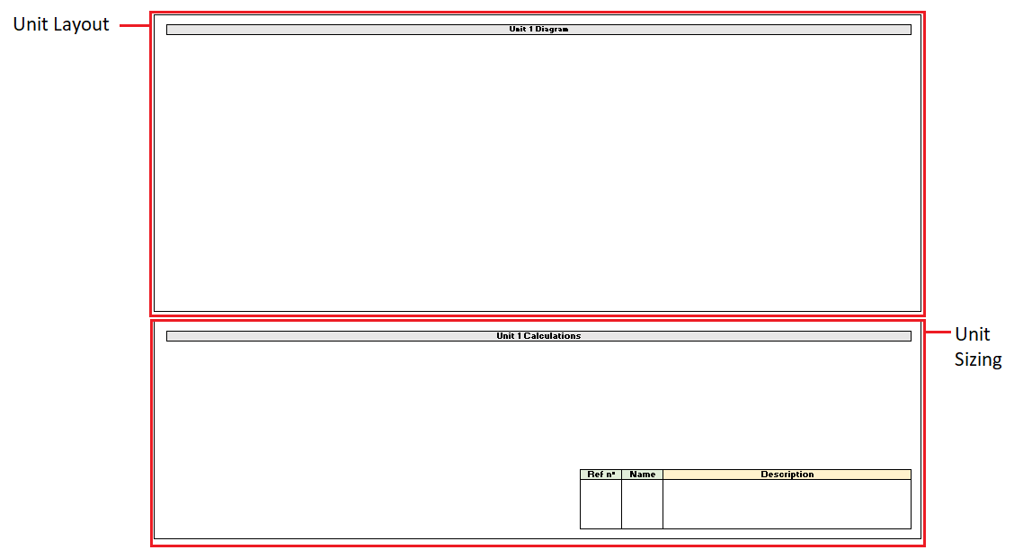

Figure 7 Equipment Estimate: plant layout and process equipment sizing sections

Further to the right of the sheet, the unit layout can be provided by the user and below, a dedicated space for unit sizing is introduced, as shown in Figure 7. Several equipment capacities for the correlations may not be directly accessible from the process simulation, and some intermediate calculations will be required before reaching the adequate input variable. Some generalized formulas for standard equipment are available, although it is recognized that the large diversity of process operations often require the specific ad-hoc calculation, using more powerful software tools for a better representation. Standard approaches for calculation of the heat exchange coefficient, by defining the stream conditions across the heat exchanger, are available. Thus, the user may specify whether the stream is liquid, gas (indicating its pressure) or if phase change occurs for each side, and the overall heat transfer coefficient allows to easily determine the exchange surface as an input for the correlation.

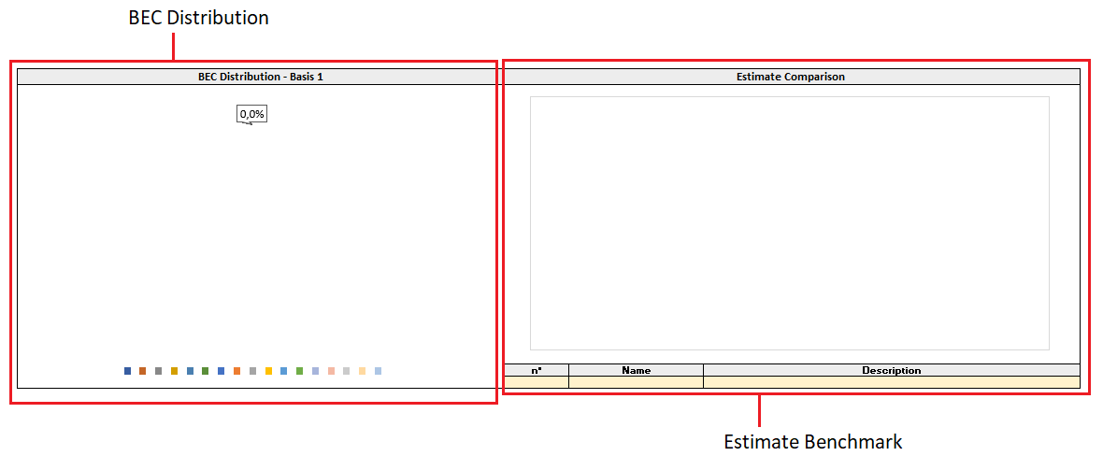

Figure 8 Equipment estimate: BEC distribution and comparison with reference sections

Finally, below the BEC estimate region, a section is created to reflect the cost proportion of items (by default those pertaining to Basis 1), as depicted in Figure 8. This section is only for informational purposes and does not affect the assessment. In addition, the user can directly compare the estimation with other literature sources providing the cost for the same unit scope (if available), as presented further to the right (ensuring appropriate scaling to the same basis). A scaled cost from the original reference can also be plotted for a benchmarking at the same unit capacity of the estimate. The references used from literature sources are listed at the bottom with a number, a short name and a suitable description. The list of all references employed based on the numbering are provided in a dedicated sheet: “Bibliography”.

## Unit – X0X – Scaling

The spreadsheet template used for cost estimates using the *Scaling Approach* described in Section 2.1.2 is reflected in Figure 9. The default coding for the cost concepts involved in the estimation are denoted with X-Y0Z coding, and a description, a source reference, currency, location and cost basis year must be introduced or selected from drop down menus. Additionally, information regarding the capacity variable and units to be scaled is provided, as well as the exponent parameters for train and unit scaling, reference cost and nº of trains, and capacity for reference and estimated units. Adjustments to the BEC estimations from the source to the target cost basis are performed in each line based on the source year, currency, and location specified.

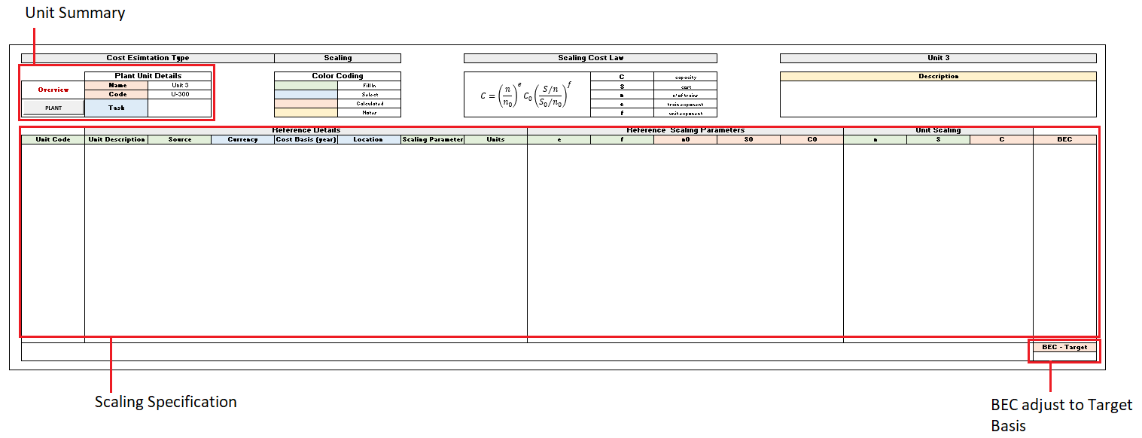

Figure 9 Scaling estimate: unit summary, scaling & Misc. items specifications and estimate adjustment sections

Analogously to the equipment type estimation, below these sections an illustration of the relative BEC distribution of the different cost concepts (for cost basis 1) is offered. Further to the right, a comparison of the estimate with the actual and scaled cost of the reference is provided. Other literature sources can be used for comparison, but the authors emphasize again that suitable adjustments be made to reach a consistent evaluation. The original scaling and benchmarking references are listed at the bottom of this area. On the right, a short list describing the items considered in each unit X-Y0Z from the reference are shown, to clarify which cost items are introduced in each concept. These sections are depicted in Figure 10.

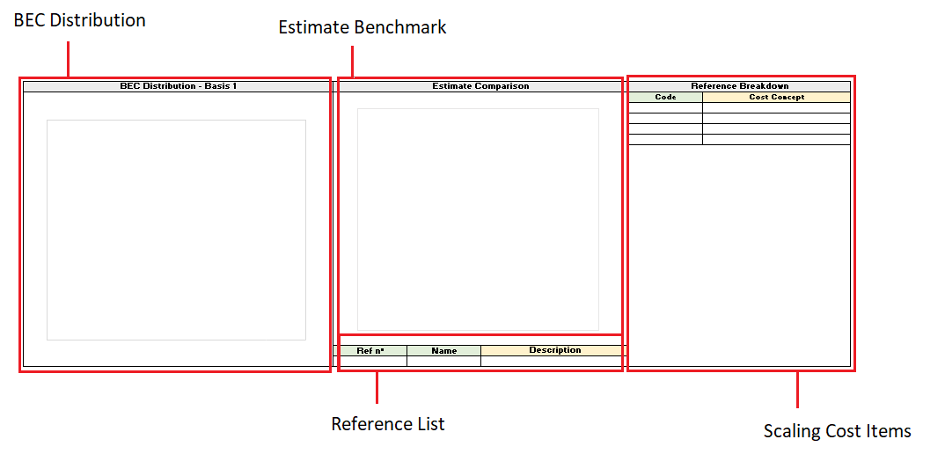

Figure 10 Scaling estimate: BEC distribution, estimate comparison, list of references and scaling cost item list sections

## Plant CAPEX

Once all plant unit BECs are estimated with either of the two approaches outlined above, the CAPEX sheet will incorporate the adjusted BEC values as shown in Figure 11. A table with headers for each plant unit name presents the BEC estimates (as the sum of the adjusted estimates in the corresponding Unit sheet). The user must ensure that the cells in row 5 (BEC) are linked to the adjusted BEC from the different Unit sheets. In the lower rows, the different cost items to arrive at the TOC and TCR values are provided. A column is added to provide a short description for each item.

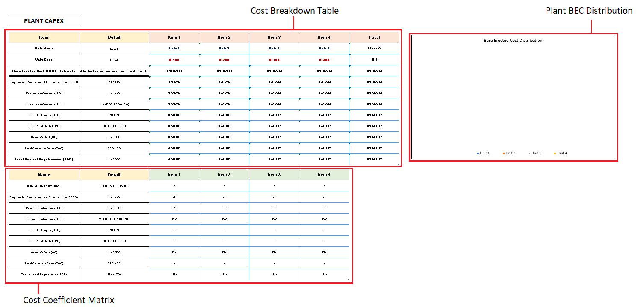

Figure 11 Plant CAPEX sheet distribution

Below, another table containing the coefficients (where applicable) for each cost item is specified as shown in Figure 12. In this way, the user can directly specify a specific value for each plant Unit. For instance, a Unit which presents a lower technological maturity will have a high process contingency factor. Further below, a summary of the estimate basis is given, as well as the total and specific capital costs (per unit of product). A shortcut button allows to add and remove new units to the evaluation when required. To the right, a BEC (at the target cost basis) distribution plot is shown. This allows the user to visualize the relative cost contribution of the units.

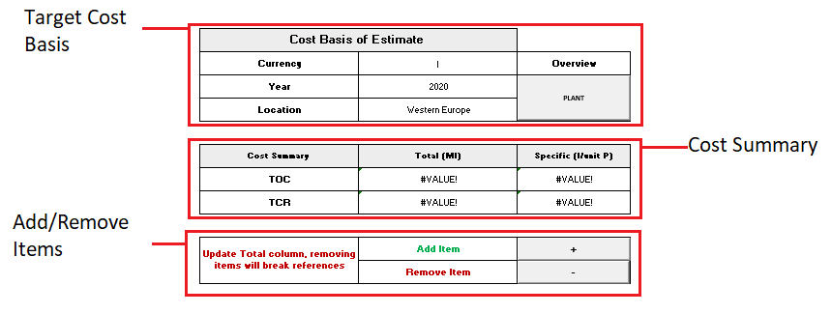

Figure 12 Plant CAPEX summary sections

## Plant OPEX

In the OPEX sheet, the Operating and Maintenance (O&M) costs are specified. The sheet distinguishes between fixed and variable O&M costs. Fixed costs represent those which are incurred on a yearly basis independent of the operating hours of the plant, such as maintenance or personnel costs. On the other hand, variable costs represent a yearly negative cash flow which depends on the capacity factor for a given year (e.g., catalyst replacement, process water costs, etc.). Fuel costs or main raw materials costs are also variable costs but are shown separately from variable O&M, as these represent a large contribution to the total. Furthermore, for plant evaluations with a specific focus on CCS, the CO2 tax component is also reflected separately from the variable O&M in the subsequent cash flow analysis, to highlight the relevance of this item in the evaluation.

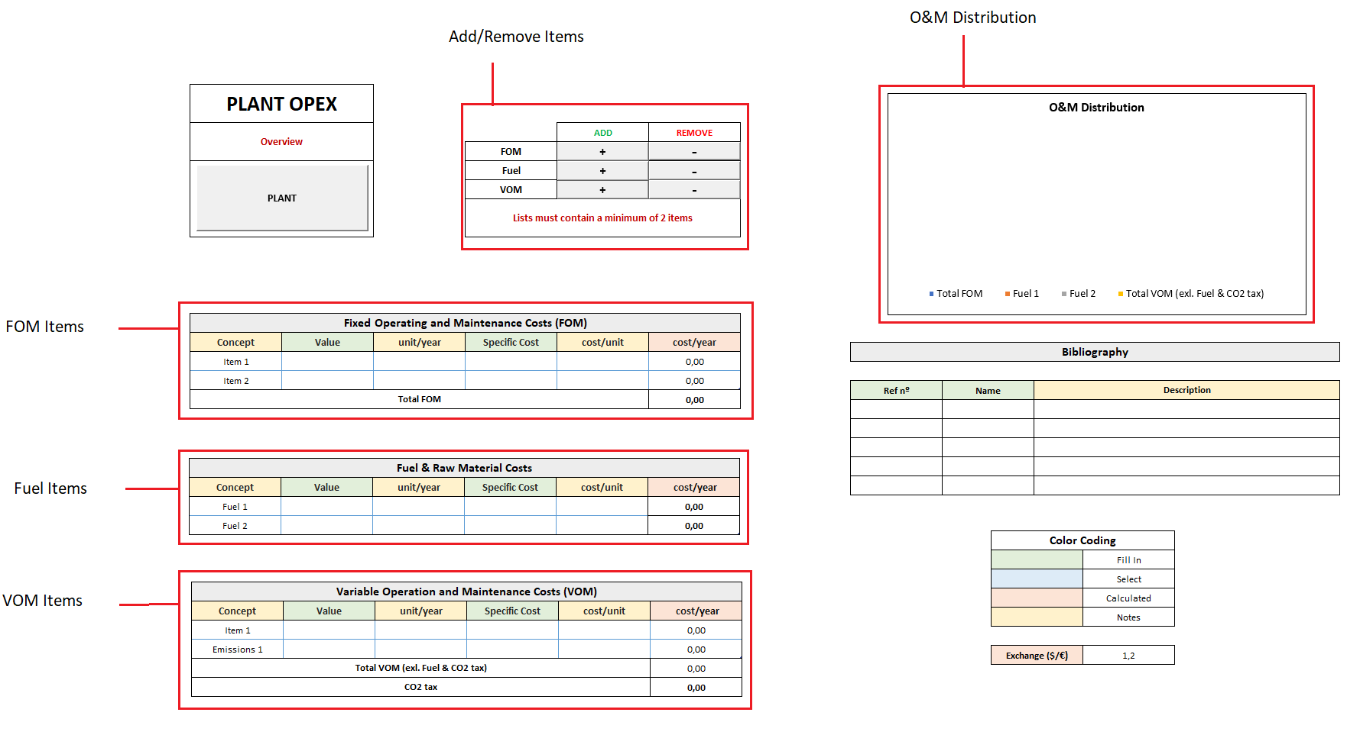

Figure 13 Plant OPEX sheet distribution

The standardized formula to introduce O&M costs using the add/remove buttons to the right requires the knowledge of a specific cost (per unit of capacity) and the yearly capacity requirement of the plant being evaluated. The cells below can be used flexibly to determine such capacities based on suitable references and plant simulation input. A yearly O&M cost distribution figure is provided to the right, to visualize the relative weight of each item.

This feature allows to assess critically if the estimate obtained is reasonable and how it compares with previous economic studies. The user can specify to up to 5 references for benchmarking. It is recommended to thoroughly verify that the benchmarking references cover the same unit scope as the estimate for a consistent comparison. The estimate and references are also compared in terms of specific costs (per unit of capacity), as shown in Figure. A dedicated section is present to place the corresponding literature sources.

## Estimate Benchmark

SEA tool offers the user to benchmark their estimates of any given unit with analogous units from literature references as shown in Figure 14. The benchmarking feature requires the specification of the estimated values and a capacity-cost scaling correlation for a defined range of capacities. Again, these correlations consider the economies of scale for a given unit and the nº of trains. Cost values from different references and source cost basis are introduced as well, providing a cost benchmark with a visual representation for the actual capacity from the source/estimate and the scaled values.

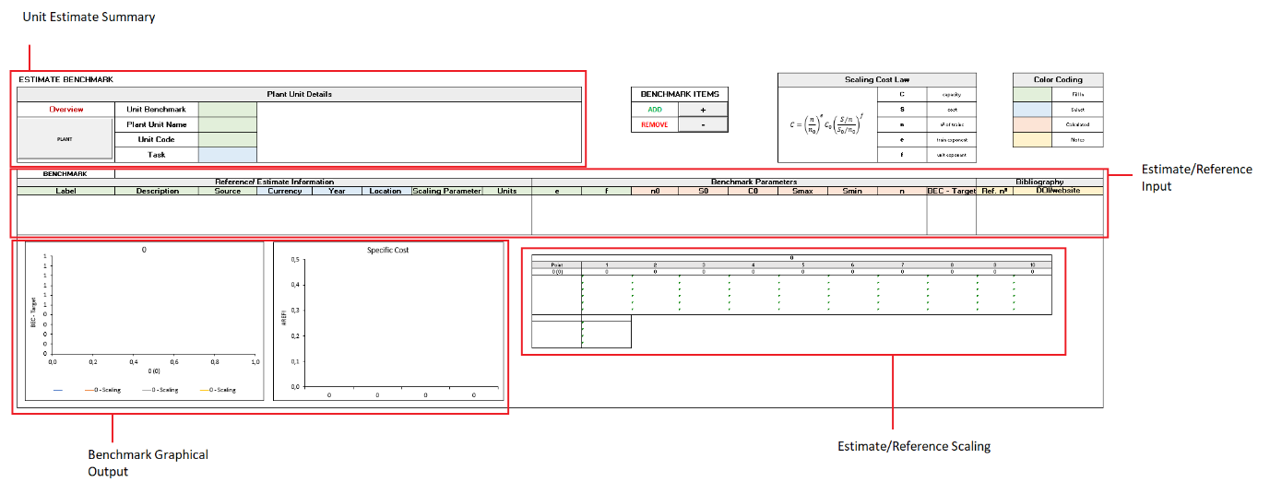

Figure 14 Estimate benchmark sheet

A macro button allows the user to add more benchmark tables according to the nº of units that need to be assessed. Reference values for cost and capacity from literature studies presented in Table 1 are recommended.

## Cash Flow Analysis

The Cash Flow Analysis sheet (CFA) presented in Figure 15 incorporates the in the top section the estimates for the TOC, FOM, VOM and fuel costs to determine several economic indicators. The user can select between determining the Levelized Cost of Product (LCOP), Internal Rate of Return (IRR) or Net Present Value (NPV) by specifying initial values for product price and discount rate and running the CFA macro. Depending on the selected economic indicator, the output table will display different values. LCOP and IRR are determined by setting Net Present Value (NPV) of the plant equal to 0 at the end of the plant economic lifetime by changing product price or discount rate, respectively. The NPV is calculated by adding the discounted annual cash flow rates during the plant construction and operational lifetime (dependant on these two input variables) as shown in Eq. 7.

|  |  |
| --- | --- |
|  | Eq. 7 |

The essential economic assumptions are included in the small table below, and the user can flexibly select the construction period and operational lifetime of the plant . Additionally, capacity factors for 1st operating and remaining years must be specified. Further below is the annual cash flow representation for each year. The user is encouraged to choose a representative capacity factor for the type of plant that is being evaluated using suitable references [14].

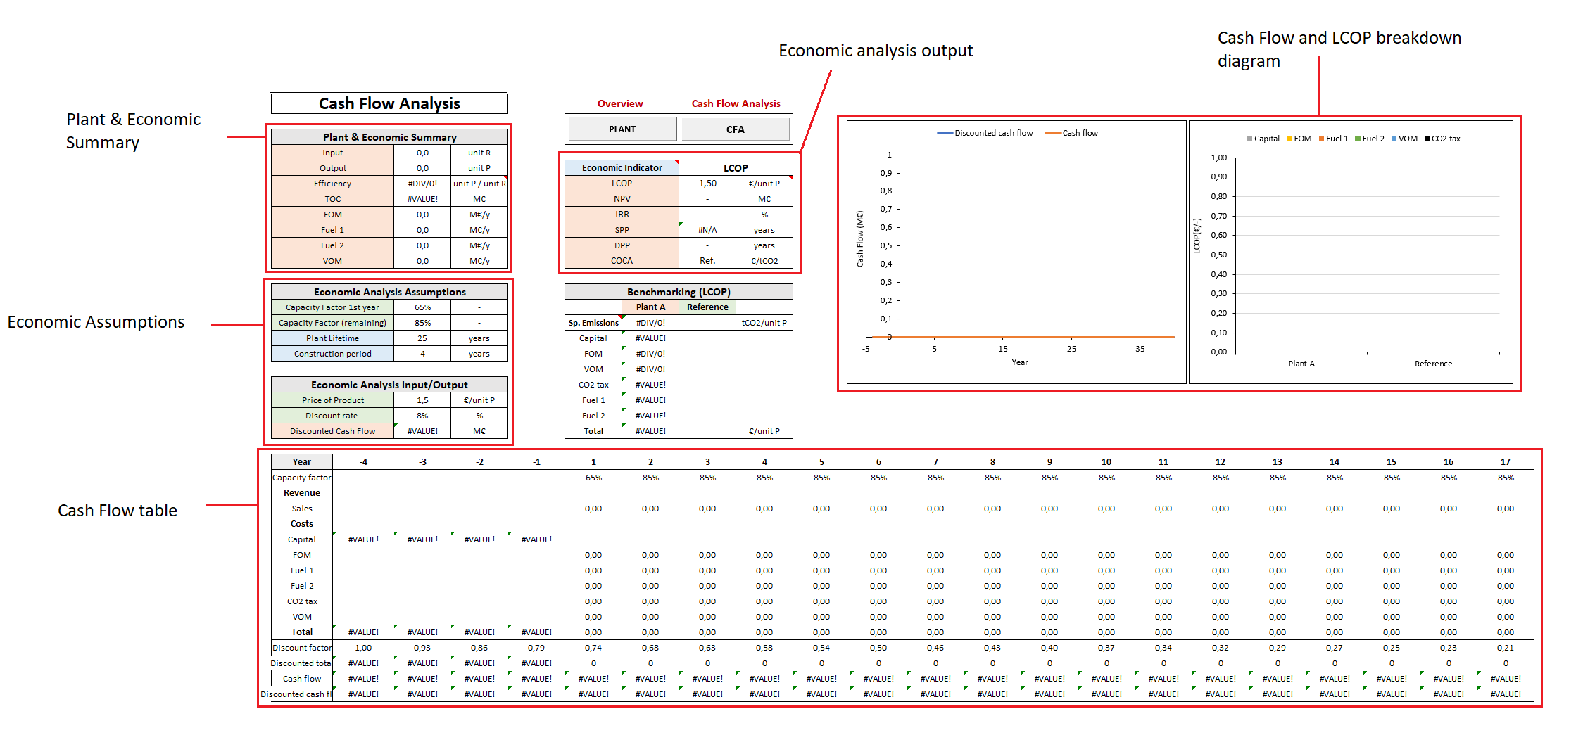

Figure 15 CFA sheet: plant summary, economic assumptions and results, LCOP breakdown and Cash Flow diagram sections

For LCOP estimations, other economic metrics can be derived when evaluating a CCS plant alternative, if several performance parameters from a reference plant without CCS are known and specified. For instance, the Cost of CO2 avoidance (COCA) defined by Eq. 8 is a common indicator to assess the potential of a CCS concept, as it directly reflects the CO2 price at which such novel plant becomes economically competitive relative to the unabated reference.

|  |  |
| --- | --- |
|  | Eq. 8 |

It is noted that for the COCA calculation specific CO2 emissions , in tons per unit of product, must be known for both reference unabated and CCS plants using a consistent methodology.

Finally, the output table also presents basic economic performance metrics: simple and discounted (if applicable) payback periods (SPP & DPP), which are defined as the plant operation year at which the respective cumulative cash flow becomes positive. To the right of the economic output table, graphical representations of the simple and discounted cash flows are shown as well as an LCOP decomposition (based on each cost item contribution) with respect a reference plant benchmark.

# Nomenclature

**Acronyms**

ACF Annualized Cash Flow

BEC Bare Erected Cost

CAPEX Capital Expenditure

CCS Carbon Capture and Storage

CEPCI Chemical Engineering Plant Cost Index

CFA Cash Flow Analysis

COCA Cost of CO2 Avoidance

DPP Discounted Payback Period

EPC Engineering Procurement and Construction

GHG Green House Gas

IEA International Energy Agency

LCOP Levelized Cost of Product

NETL National Energy Technology Laboratory

NPV Net Present Value

OPEX Operational Expenditure

O&M Operation and Maintenance

TCR Total Capital Requirement

TPC Total Plant Cost

TOC Total Overnight Costs

TRL Technology Readiness Level

SPP Simple Payback Period

**Symbols**

Cost estimate

Purchased cost with carbon steel at 1 bar

Bare Module cost

Diameter (m)

Pressure factor

Material factor

Bare Module factor

Location factor

Pressure (bar)

Capacity

Specific CO2 emissions

Discount rate

nº of trains, plant lifetime

Construction period

Train exponent

Unit exponent

# References

[1] J.M. Klara, M. Woods, O.J. Capicotto, J.T. Haslbeck, M. Matuszewski, L.L. Pinkerton, M.D. Rutkowski, R.L. Schoff and V. Vaysman, "Cost and performance baseline for fossil energy plants" *National Energy Technology Laboratory, DOE/NETL-2007/1281.* 2007.

[2] R.2. DOE/NETL-2010/1397, "Cost performance baseline for fossil energy plants. Volume 1: Bituminous coal and natural gas to electricity " *performance baseline for fossil energy plants.Volume 1: Bituminous coal and natural gas to electricity.* 2013.

[3] A. Zoelle, D. Keairns, M.J. Turner, M. Woods, N. Kuehn, V. Shah, V. Chou, L.L. Pinkerton and T. Fout, "Cost and Performance Baseline for Fossil Energy Plants, Volume 1: Bituminous Coal and Natural Gas to Electricity, Revision 4" *Cost and Performance Baseline for Fossil Energy Plants Volume 1b: Bituminous Coal (IGCC) to Electricity Revision 2b–Year Dollar Update.* 2015.

[4] A.J. Zoelle, M.J. Turner, M.C. Woods, James III PhD, Robert E, T.E. Fout and T.R. Shultz, "Cost and Performance Baseline for Fossil Energy Plants, Volume 1: Bituminous Coal and Natural Gas to Electricity, Revision 4" *Cost and Performance Baseline for Fossil Energy Plants, Volume 1: Bituminous Coal and Natural Gas to Electricity, Revision 4.* 2018.

[5] IEAGHG R&D Programme, "Effects of Plant Location on the Costs of CO2 Capture, Technical Report" 2018.

[6] Plant Cost Index Archives - Chemical Engineering<http://www.chemengonline.com> 2018.

[7] R. Turton, R.C. Bailie, W.B. Whiting and J.A. Shaeiwitz, "Analysis, synthesis and design of chemical processes", 2008.

[8] K.M. Guthrie, "Data and Techniques for Preliminary Capital Cost Estimating", 1969.

[9] W.D. Seider, J.D. Seader and D.R. Lewin, "PRODUCT & PROCESS DESIGN PRINCIPLES: SYNTHESIS, ANALYSIS AND EVALUATION, (With CD)", 2009.

[10] Robin Smith, "Chemical Process Design and Integration" John Wiley & Sons Ltd, 2005.

[11] R. Anantharaman, O. Bolland, N. Booth, E. Van Dorst, E. Sanchez Fernandez, F. Franco, E. Macchi, G. Manzolini, D. Nikolic, A. Pfeffer, M. Prins, S. Rezvani and L. Robinson, "Cesar Deliverable D2.4.3. European Best Practice Guidelines For Assessment Of Co2 Capture Technologies" 2018.

[12] C.O. IEAGHG, "Capture at coal based power and hydrogen plants, Report 2014/3" 2014.

[13] M. Babcock, "Oxy combustion processes for CO2 capture from power plant" *IEA, Report.* 2005, no. 2005/9.

[14] S. Roussanaly, E. Rubin, M.V. Der Spek, N. Berghout, G. Booras, T. Fout, M. Garcia, S. Gardarsdottir, M. Matuszewsk and S. McCoy, "Towards improved guidelines for cost evaluation of CO2 capture technologies" 2019.